Create a React Application “eventexamplesapp” to handle various events of the form elements in HTML.

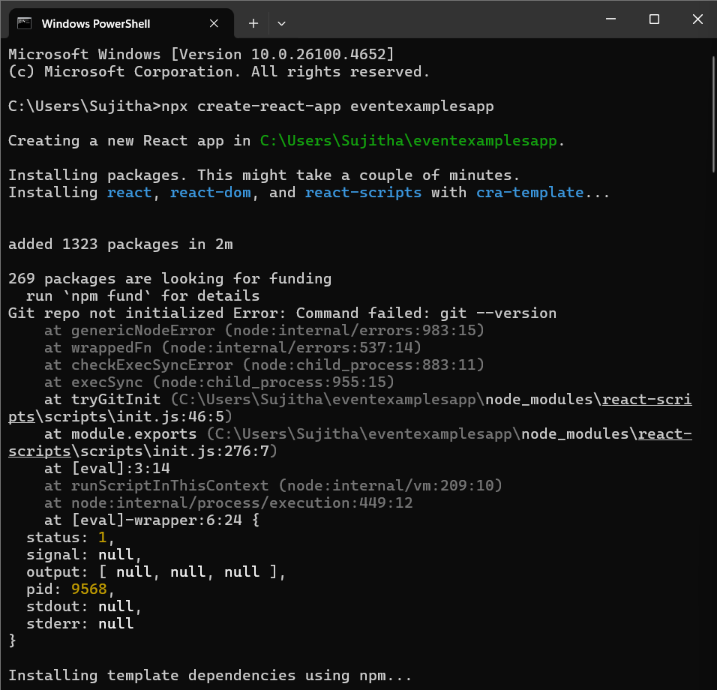

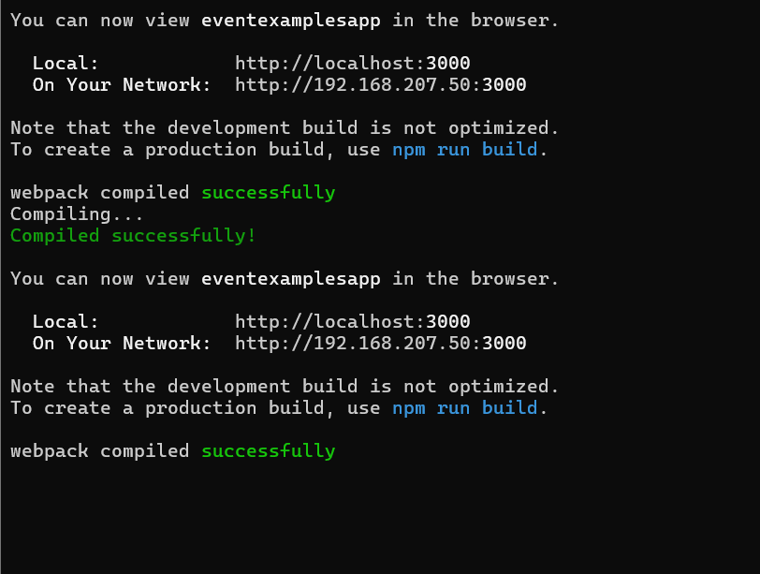

**App.js**

import React from 'react';

import Counter from './Components/Counter';

import WelcomeButton from './Components/WelcomeButton';

import SyntheticEventButton from './Components/SyntheticEventButton';

import CurrencyConvertor from './Components/CurrencyConvertor';

function App() {

  return (

    <div className="App">

      <h1>React Event Examples</h1>

      <Counter />

      <br />

      <WelcomeButton />

      <br />

      <SyntheticEventButton />

      <br />

      <CurrencyConvertor />

    </div>

  );

}

export default App;

**Counter.js**

import React, { useState } from 'react';

function Counter() {

  const [count, setCount] = useState(0);

  const increment = () => {

    setCount(count + 1);

    sayHello();

  };

  const decrement = () => {

    setCount(count - 1);

  };

  const sayHello = () => {

    console.log("Hello! Count increased.");

  };

  return (

    <div>

      <h2>Counter: {count}</h2>

      <button onClick={increment}>Increment</button>

      <button onClick={decrement}>Decrement</button>

    </div>

  );

}

export default Counter;

**WelcomeButton.js**

import React from 'react';

function WelcomeButton() {

  const sayWelcome = (msg) => {

    alert(`Say: ${msg}`);

  };

  return (

    <button onClick={() => sayWelcome("Welcome")}>Say Welcome</button>

  );

}

export default WelcomeButton;

**SyntheticEventButton.js**

import React from 'react';

function SyntheticEventButton() {

  const handleClick = (e) => {

    alert("I was clicked");

    console.log("Synthetic Event:", e);

  };

  return (

    <button onClick={handleClick}>Click Me</button>

  );

}

export default SyntheticEventButton;

**CurrencyConvertor.js**

import React, { useState } from 'react';

function CurrencyConvertor() {

  const [rupees, setRupees] = useState('');

  const [euro, setEuro] = useState('');

  const handleSubmit = () => {

    const result = (parseFloat(rupees) / 90).toFixed(2); // Assuming 1 Euro = ₹90

    setEuro(result);

  };

  return (

    <div>

      <h3>Currency Converter</h3>

      <input

        type="text"

        placeholder="Enter amount in ₹"

        value={rupees}

        onChange={(e) => setRupees(e.target.value)}

      />

      <button onClick={handleSubmit}>Convert</button>

      <p>Amount in Euro: €{euro}</p>

    </div>

  );

}

export default CurrencyConvertor;

**output**

